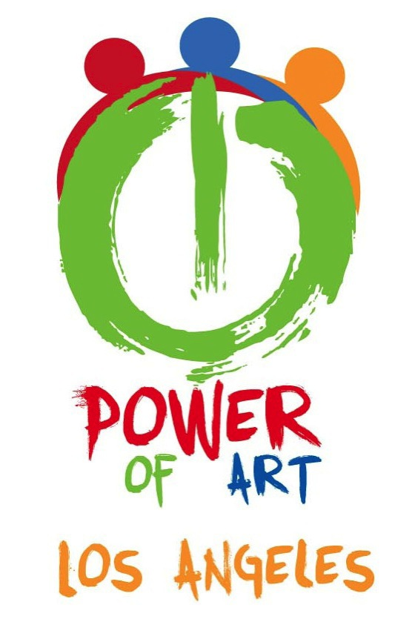

Business 499 Business Plan

Table of Contents

1.0 Executive Summary............................................................................................. 4

2.0 What is Power of Art........................................................................................... 6

2.1 Industry Landscape (Economic Analysis)...........................................................7
2.2 The Economic impact of Graffiti Removal)....................................................9
2.3 The Economic Impact of Changing the Landscape............................................11
3.0 Power of Art’s Organization……………………..............................................................13
3.1 The Founders……………………....................................................................13, 14
3.2 Non-profit Organization…………………............................................................15
4.0 Strategy and Implementation ………………….............................................................16
4.1 Organization Strategy …………………...............................................................16
4.2 Implementation …………………........................................................................17
4.3 Goals and Objectives…………………................................................................ 20
4.4 Marketing Strategy…………………................................................................... 21
5.0 Financial Plan…………………........................................................................................22
5.1 Projected Profit and Loss Statement…..……..................................................23

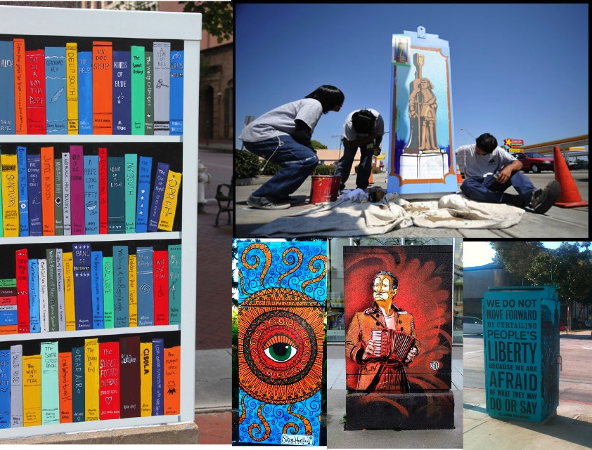

1.0 Executive Summary

Mission/Vision:

The Power of Art’s mission is to enable artists, organizations, and everyday people to paint murals on traffic signal boxes and in crosswalks on more than 4,000 street corners in Los Angeles. The vision of Power of Art is to unite and inspire Los Angeles’s artists, organizations, and everyday people by giving them the opportunity to leave their creative mark on history through artistically transforming their communities.

Phases:

Power of Art will operate in six separate but interrelated phases: a vision/mission phase designed to articulate the goals and aspirations of the project; a persuasion/partnership phase to identify, recruit, and mobilize potential project collaborators in the public, private, and civic sectors; a pre-submission/pre-rollout phase designed to solicit mural submissions from artists, and organizations; a fundraising stage to secure funds to pay artists, buy materials, and give prizes; an implementation phase to begin mural paintings; and an after-action analysis stage to assess what went right, what went wrong, and how to improve the program in the future.

Economic/Landscape Analysis:

Los Angeles is considered the artistic capitol of the world, with the creative industry (including motion picture and entertainment) generating more than $200 billion a year in revenue. There are more than 300 museums, 200 galleries, and countless artists who live in the region. That said, according to experts in the arts industry, many artists are underemployed and have no outlet to express their creativity. As a result, many end up illegally painting public and private properties, causing more than $30 million in graffiti removal costs yearly. There has been no solution to date for this.

Competitive Advantages:

The Power of Art is an organization that exists to unite museums, galleries, and artist “collectives,” many of whom view one another as competitors. As a neutral convener, Power of Art can build the credibility and trust among those in the creative industry who normally do not collaborate because Power of Art is not viewed as a rival organization. In addition, the Power of Art has exclusive, government-backed access to every traffic signal box, crosswalk, and bus in the City of Los Angeles to “muralize.”

Organization:

The organization is comprised of two “co-founders,” one of whom handles finances and administration and the other who handles business development and curation. It is building an advisory board made up of leading public, private, and civic sector officials and will hire a full-time executive director and staff assistant to handle daily operations across several departments (“staffed” by volunteers).

Financials Summary:

The Power of Art seeks an investment of $100,000 for 2014-2015 project implementation ($30,000 for artist prizes, $25,000 for administration costs, and $50,000 for marketing). It will need $150,000 for FY 2015-2016 and $200,000 for FY 2016-2017 for profitability.

2.0 What is the Power of Art?

Due to budget cuts and widespread “graffiti,” many areas of Los Angeles appear blighted. The Power of Art: Unveiling Los Angeles’s Soul in the Streets is the grassroots response to this. By organizing artists, organizations, and everyday people, the Power of Art seeks to beautify Los Angeles by legally investing in its artistic and urban landscape. By doing so, it may decrease LA’s graffiti removal costs and potentially increase foot traffic—and revenue—for local merchants.

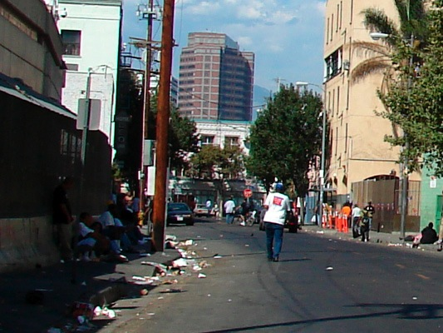

2.1 Industry Landscape (Economic Analysis):

The creative industry in Los Angeles is the region’s largest economic driver. With over $200 billion in direct annual sales, the arts define LA as much as Wall Street defines New York. Over 642,000 people are employed directly or indirectly in the industry; $3.3 billion in local and state taxes are generated; and 20% of tourists visit because of the industry, which contributes to over 30% of all tourism revenues—nearly $6 billion dollars. Despite generating $200 billion in sales annually, however, most of the “creative industry” is financially dominated by the motion picture and entertainment industries. However, there are over 14 other industries in the arts that contribute to the health, vitality, and financial tapestry of the overall creative industry. Museums, art dealers, and visual artists, for example, contribute a large, but unspecified, amount of dollars to the creative industry each year. (Unfortunately, the financial impact of these industries are not tracked because local economists usually focus on the biggest industries in the arts, the motion picture and entertainment industries, and do not provide public data for the rest.) Regardless, in comparison to the motion picture and entertainment industries, these other industries in the arts only contribute a sliver of the $200 billion the overall creative industry generates.

This means that, although Los Angeles has tens of thousands of artists outside of motion pictures and entertainment according to the LA Arts Commission, they are not contributing a substantial part to the industry or economy. However, this does not mean that they cannot. Interviews done with local artists including the “Black Light King,” Danielle Gibson, and Oscar Magallanes—artists who work in downtown, the East Side, and the West Side of Los Angeles, respectively—indicates most of the “arts’” industries in LA are “greatly underperforming”. Economically, this means that there may be an 1) underemployment of artists, 2) potential reduced industry revenue, and 3) potential reduced city and state tax revenue. The underemployment impacts LA in other ways as well. Artists seek alternative, non-monetary channels to display their creativity such as painting on properties without permission. Many artists paint these works as a way to brand and market themselves, and increase the value of their work. Unfortunately, this strategy rarely works for artists. In fact, it has been counterproductive because their work usually ends up getting “buffed” or erased quickly, which costs the government millions to clean up annually.

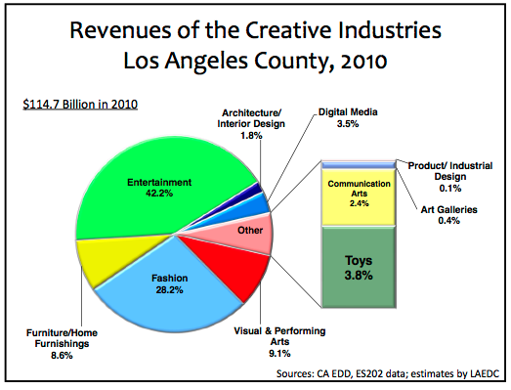
2.2 The Economic Impact of Graffiti Removal

The County of Los Angeles spends more than $30 million every year in removing illegal “graffiti.” Graffiti is defined as writings or drawings scratched, scribbled or painted illicitly on a wall or surface in a public place. The $30 million erases thousands of public arts pieces created without approval. In addition, for artists that leave their “names” on their work the government issues a financial penalty and felony charge to recoup the costs of graffiti removal. But graffiti removal has other implications that are not so obvious. According to the Los Angeles Department of Cultural Affairs, it is difficult for the government to work with artists on public arts projects. Interviews revealed that the graffiti removal penalties issued have led artists to resent and distrust the government. Confidential sources in the Department of Cultural Affair and El Pueblo de Los Angeles implicated that politicians may not want artists to produce less graffiti because it could cause problems for them. As a result, graffiti removal companies would receive less funding because there would be less graffiti to remove. Often the graffiti removal companies are financially supported by their political campaigns and would pull their support.

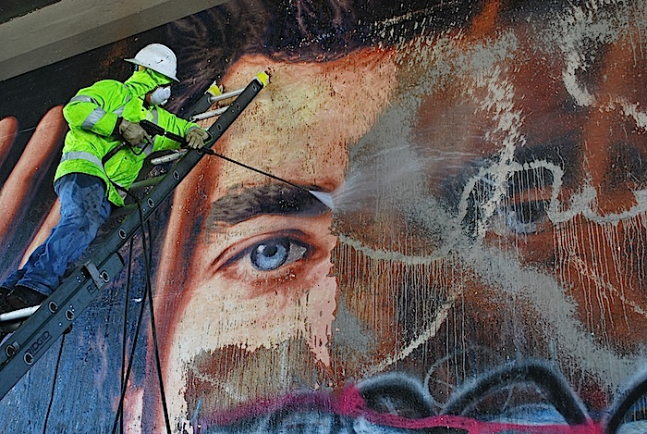

2.3 The Economic Impact of Changing the Urban Landscape

Despite the claim from government officials that privately politicians may not want less graffiti, publicly the government’s goal is to reduce graffiti costs. The Los Angeles Department of Transportation (LADOT) outlined one way to do this starting in 2012. They launched a public “decorative display” campaign that encourages artists to legally paint on their signal boxes on every corner of Los Angeles. According to Selwyn Hollins, the Deputy General Manager of LADOT, the logic behind this would be to give artists a legal outlet to display their work so that graffiti costs could be reduced, artists could avoid felony charges and penalties; and potentially increase business foot traffic. In the two years since the campaign has been launched, only 43 artists have responded to LADOT’s invitation. The reasons for this could vary, but according to Hollins this is because LADOT cannot reach the artists. Because there has been such a limited response, LADOT does not keep public or private data on how the 43 paintings have economically altered the local businesses they may be painted near. Other cities, such as Pasadena, California; Jackson, Missisippi; Missouli, Montana; and Seattle, Washington also do not keep public or private data on how paintings on their traffic signal boxes impact local merchants. Hollins indicated that local transportation officials are not interested in the economic impact, but merely whether the paintings “improve” aesthetics.
It is unclear whether the traffic signal boxes increased foot traffic of businesses with data available. Interviews and observation could not show results without previous data. It remains to be seen how painted traffic signal boxes in LA might affect local merchants, particularly retailers and restaurants. Of the 43 traffic signal boxes painted so far in LA, Hollins is unsure how many are near merchants. Only time will tell if the traffic signal boxes will have an impact on the local economy in terms of increased foot traffic and, relatedly, increased sales.

3.0 Power of Art’s Organization

3.1 Founders:

The Power of Art was co-founded by Mai-Ly Spiller, an artist and the CEO of DesignSpillz, and Rob Carpenter, a serial entrepreneur and former LA Transportation Commissioner. Ms. Spiller’s DesignSpillz is a platform for artists—both discovered and undiscovered—to commercialize their work. Mr. Carpenter has successfully started multiple companies, nonprofits, and public campaigns around the world. Their biographies are as follows:

Mai-Ly Spiller Biography

Mai-Ly Spiller is on a mission to change the world. As an artist, entrepreneur, designer, and global collaborator, she has worked on projects with stars from American Idol, America's Next Top Model, CSI: Miami, and others to bring awareness and action to social causes throughout the world, including clean water, climate change, children with diseases, and many more. She has used her company, DesignSpillz, as a platform for undiscovered artists, designers, and everyday people to use their creative skills for the first time within and outside of commercial markets to create change. And she has partnered with universities and cities to create cutting edge social campaigns. Mai-Ly is a first generation American, hails from a family of entrepreneurs (in medicine, aerospace engineering, construction, real estate and finance), and has tirelessly worked three jobs to earn degrees in technology and business from California State University, Los Angeles, without taking on student debt. Recently, Mai-Ly has been selected as a Global Innovation Fellow to work with Facebook, Google, the Creative Artist Agency, and the to figure out next-generation solutions to global problems.

Rob Carpenter Biography

Rob Carpenter is a serial 'hybrid entrepreneur,' venture capitalist, professor, writer, public speaker and social activist. He has worked in the White House Office of Political Affairs and for former U.S. House Speaker, focusing on both domestic and foreign policy. Rob has served as the Special Assistant to the CEO of Teach For America; was appointed as the youngest Commissioner of Transportation in the history of Los Angeles at 24 years old, where he saved over 100 ambulance worker jobs and exposed more than $217 million in fraudulent City funds as reported by the LA Times; served as a leader in passing a $40 billion ballot measure to build Los Angeles's "Subway to the Sea"; and has served as professor of innovation at California State University, Los Angeles. He has founded numerous ventures, including a multi-million dollar startup named an "Emerging Technology Company of the Year" by Tech America, the Global Innovation Fellows, and more recently a venture capital firm that will be launching an asteroid-mining company. Rob holds a Master's Degree from Northwestern University and his writings and ventures have appeared in the New York Times, People Magazine, CNN, NBC, ABC, and Bloomberg BusinessWeek among others.

3.2 Nonprofit Organization:

The Power of Art is organized as a fiscally sponsored nonprofit, the fiscal sponsor being Master’s Workshop, a local arts nonprofit. The nonprofit will be organized in the following functional areas:

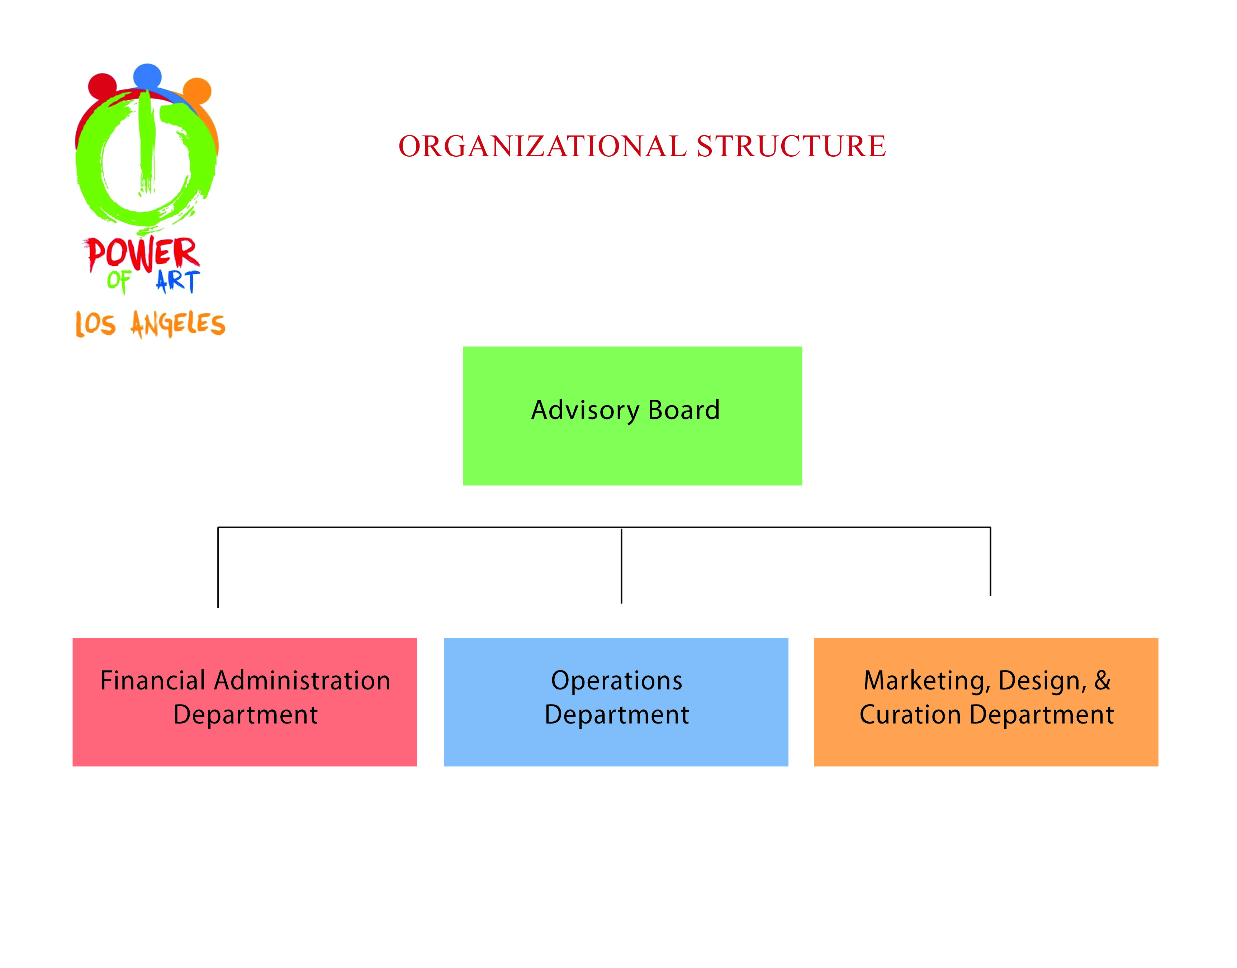
- Advisory Board. The Advisory Board will be responsible for working with the co-founders; defining the mission, vision, and strategy of the organization; and raising capital.

- Financial Administration Department. This Department will be responsible for managing the Power of Art’s finances, including payroll, reporting, IT, human resources, and other functional areas of the nonprofit.

- Marketing, Design, & Curation Department. This group is responsible for branding; marketing strategy; artist recruitment and selection; and public relations.

- Operations Department. The Operations Department will be responsible for implementing Power of Art’s strategy and overseeing logistics of all departments.

4.0—Strategy and Implementation

4.1 Organization Strategy:

The Power of Art’s strategy is to help Los Angeles decrease graffiti removal costs by mobilizing artists, organizations, and everyday people to legally paint art on existing city infrastructure (i.e., traffic signal boxes, crosswalks, and buses). By collaborating with established organizations—the Los Angeles Department of Transportation; Los Angeles Department of Cultural Affairs; El Pueblo de Los Angeles; Creative Artist Agency; LA County Arts Commission; etc—Power of Art will use its partners’ resources to raise capital, recruit artists, and market itself.

4.2 Implementation:

Power of Art will implement its strategy in six phases. a vision/mission phase; a persuasion/partnership phase; a pre-submission/pre-rollout phase; a fundraising stage to secure; an implementation phase; and an after-action analysis stage.

4.21 Phase 1: Vision/Mission

During this phase, Power of Art’s vision and mission will be established. Various community stakeholders—government officials, nonprofit leaders, educators, artists, and others—will be solicited for their expertise. Stakeholder opinions will be incorporated into goals and objectives of project.

4.22 Phase 2: Persuasion/Partnership

During this phase, POA will seek strategic partners to gain exclusive access to traffic signal boxes, crosswalks, buses, and billboards of Los Angeles. This will require POA to partner with the Los Angeles Department of Transportation (LADOT), America’s second largest transportation organization. LADOT controls 4,400 traffic signal boxes, 6,000 miles of street crosswalks, and other assets integral to the success of the POA campaign. POA will also need to, at a minimum, partner with the Los Angeles Department of Cultural Affairs, the official government group that oversees all murals and public art in the City. And finally, it will be necessary to partner with El Pueblo de Los Angeles, the historic conservation group that oversees the birthplace location of LA—Olvera Street—and various museums.

It will also be crucial to partner with non-governmental organizations to recruit/mobilize artists, publicize our efforts, and raise funds. Potential partners include Creative Artists Agency, Clear Channel Media & Entertainment, eBay Charity, and various arts groups throughout Los Angeles and beyond.

4.23 Phase 3: Pre-Submission/Pre-Role Out

Prior to the public announcement of the campaign, we will execute a “demonstration” project that will paint nearly 4 dozen signal boxes (a “mini-mural” on every street corner) as well as one or two crosswalks. This will enable us to review, on a pilot basis, the time necessary to paint boxes (on average) and any other logistical issues that will need to be adjusted prior to a “city-wide” role out. It will also allow us to assess an initial analysis for the murals social and economic impact.

4.24 Phase 4: Fundraising

As with any large, historic campaign, funds will be necessary for its successful implementation. That said, POA has a multi-tired fundraising strategy that will tap its network to generate finances. In particular, the Power of Art will conduct traditional fundraising—donation letters, happy hour and cocktail fundraisers, donor meetings, and the like—as well as create “incentive experiences.” Incentive experiences will allow small level donors to donate to the cause in exchange for them being entered into raffles to win unique “experiences” (i.e., a lunch with Bill Gates, a private tour of the City with the Mayor of Los Angeles, a ride down Pacific Coast Highway with Johnny Newman, etc.). In total, POA would like to raise a minimum of $100,000 to conduct this project.

4.25 Phase 5: Implementation

In this phase, POA will announce through various media and mass market efforts that the city of Los Angeles will be turned into “the world’s largest art gallery.” Artists will begin submitting their work online to www.powerofart.org for review and approval. Once accepted, they will receive an e-mail to begin work on their boxes. All 4,400 boxes will be painted during this phase. Chosen artists will win prizes.

4.26: After-Action Analysis

In this phase, will we conduct a review of the campaign to see what was done properly, what could be improved, and best practices that could be passed on to other cities/locales.

4.3 Goals and Objectives:

The Power of Art has 4 primary goals:
- To create a mini-mural on every street corner
- To create murals within cross walks on some major street corners
- To wrap buildings, buses, billboards, and benches in beautiful, diverse art
- To decrease graffiti removal costs for the City of Los Angeles

The Power of Art has 10 primary objectives:

- To give a voice to the people who usually never have a chance to express themselves, their ideas, and their artistic talents publicly
- To Provide a citywide platform for our vast hub of artists to be “discovered”
- To inspire people to think more deeply about art and its positive messages and benefits for society
- To change the way artists think about community and the way the community thinks about art and artists
- To showcase a multitude of diverse, historic, iconic, creative, global and neighborhood art and art forms
- To showcase the untold stories of the people of Los Angeles
- To bring a sense of appreciation to the untapped talent and history of everyday people and our neighborhoods
- To demonstrate that though Los Angeles is many voices, it is really ONE voice
- To bring healing, identity, unity and civic pride to the City by unifying its diverse individuals, artists, organizations, and neighborhoods with ONE city-wide community project
- To beautify the streets of LA Showcasing to the world that Los Angeles really is the planet’s most artistic and creative place
- To bring unprecedented positive publicity to the City by breaking potential world records To give people the chance to leave their creative mark on history

4.4 Marketing Strategy

The Power of Art’s marketing strategy has identified six primary stakeholders to market to: the City of Los Angeles (i.e., the government); organizational partners; artists; schools; businesses; and the public. The financial plan provides direct marketing to these stakeholders.

The Power of Art’s initial promotional strategy will be to persuade key government organizations (the Los Angeles Department of Transportation, Cultural Affairs, El Pueblo de Los Angeles, City Council, and Mayor’s Office) to grant exclusive access to traffic signal boxes, crosswalks, and buses.

It will then target organizational partners outside of the government (Creative Artist Agency, Clear Channel Communications, the Annenberg Foundation, LA 2050, and various museums/galleries) to assist in advertising, fundraising, and mass artist recruitment.

Power of Art will then directly reach out to individual artists and art collectives (i.e., Black Light King, Danielle Gibson, etc.) to paint on City infrastructure.

And finally, Power of Art will reach out to the Los Angeles Unified School District and local businesses and Neighborhood Councils to encourage them to submit mural paintings in their neighbors.

5.0 Financial Plan
The Power of Art project requires $450,000 in total startup costs over three years. Its primary revenue mechanism is “curated celebrity experiences.” (A curated celebrity experience is a fundraiser a celebrity agrees to host; for example, fans will pay between $10 dollars each to enter a raffle to have dinner with Brad Pitt. These types of fundraisers generate approximately $5,000-$50,000 depending on the celebrity.) In year one, the organization will be unprofitable but will turn a profit in years two and three. Its biggest expenses are consulting costs (for independent contractors to manage the project since full-time staff will not be desired) and commission costs for the curated celebrity experiences (run by “auction houses”). The second biggest cost will be purchasing supplies for a limited number or artists and awarding cash prizes to the three artists with the best murals annually. And finally, there are other standard office and organizational expenses.

5.1 Projected Profit and Loss Statement

Power of Art Pro Forma Profit & Loss Statement
 |  |  | FY 2014 |  | FY 2015 |  | FY 2016
Sales
Celebrity Experiences (Fundraiser) |  |  | $100,000 |  | $150,000 |  | $200,000
Cost of Sales (Commission) |  |  | $20,000 |  | $30,000 |  | $40,000
Gross Profit |  |  | $80,000 |  | $120,00 |  | $160,00
Gross Margin |  |  | 80% |  | 80% |  | 80%
Operating Expenses
Consulting Salaries (Independent Contractors) |  |  | $25,000 |  | $50,000 |  | $100,00
P/R Taxes/Benefits |  |  | $0 |  | $0 |  | $0
Utilities/BldgExp |  |  | 0 |  | $12,300 |  | $12,300
Telephone |  |  | $1,200 |  | $1,200 |  | $1,200
Supplies/Prizes |  |  | $30,150 |  | $50,000 |  | $50,000
Postage |  |  | $0 |  | $350 |  | $450
Stationary/Postg |  |  | $0 |  | $600 |  | $750
Equipment Purchases |  |  | $0 |  | $2,400 |  | $1,250
Depreciation |  |  | $0 |  | $0 |  | $1,200
Repairs/Rent Equipment |  |  | $0 |  | $0 |  | $0
Local Transport |  |  | $500 |  | $750 |  | $750
Advertising/Publicity |  |  | $50,000 |  | $10,000 |  | $10,000
Business Services & Fees |  |  | $3,400 |  | $4,500 |  | $4,500
Insurance |  |  | $0 |  | $1,200 |  | $1,200.0
Total Expenses |  |  | $110,250 |  | 133,300 |  | $183,65
Net Profit |  |  | -$10,250 |  | $16,700 |  | $16,350

5.2 Personnel Plan

Celebrity Experiences Fundraisers | estimated to raise $50,000 per celebrity. An initial two celebrity experiences in year 2014, three in 2015 and 4 in 2016.
Cost of Sales | Twenty percent commission costs to the auction house administrating celebrity experiences
Consulting Salaries | Paid to the Executive Director and Staff Assistant
Utilities/ Building Expenses | Cost of office space. Year 2014 will not yet have a location.
Supplies/ Prizes | Prizes money will be for winners of power box competition. Prize one $15,000 Prize two $10,000 and $5,000. Also includes certificate costs
Equipment Purchases | Computer and Printer costs
Advertising/ Publicity | 12 week radio advertising through Clear Channel Media
Business Services and Fees
Accountant | Year 2014 $1,275 Year 2015 and 2016 $1688
Lawyer | Year 2014 $2,125 Year 2015 and 2016 $2,812

