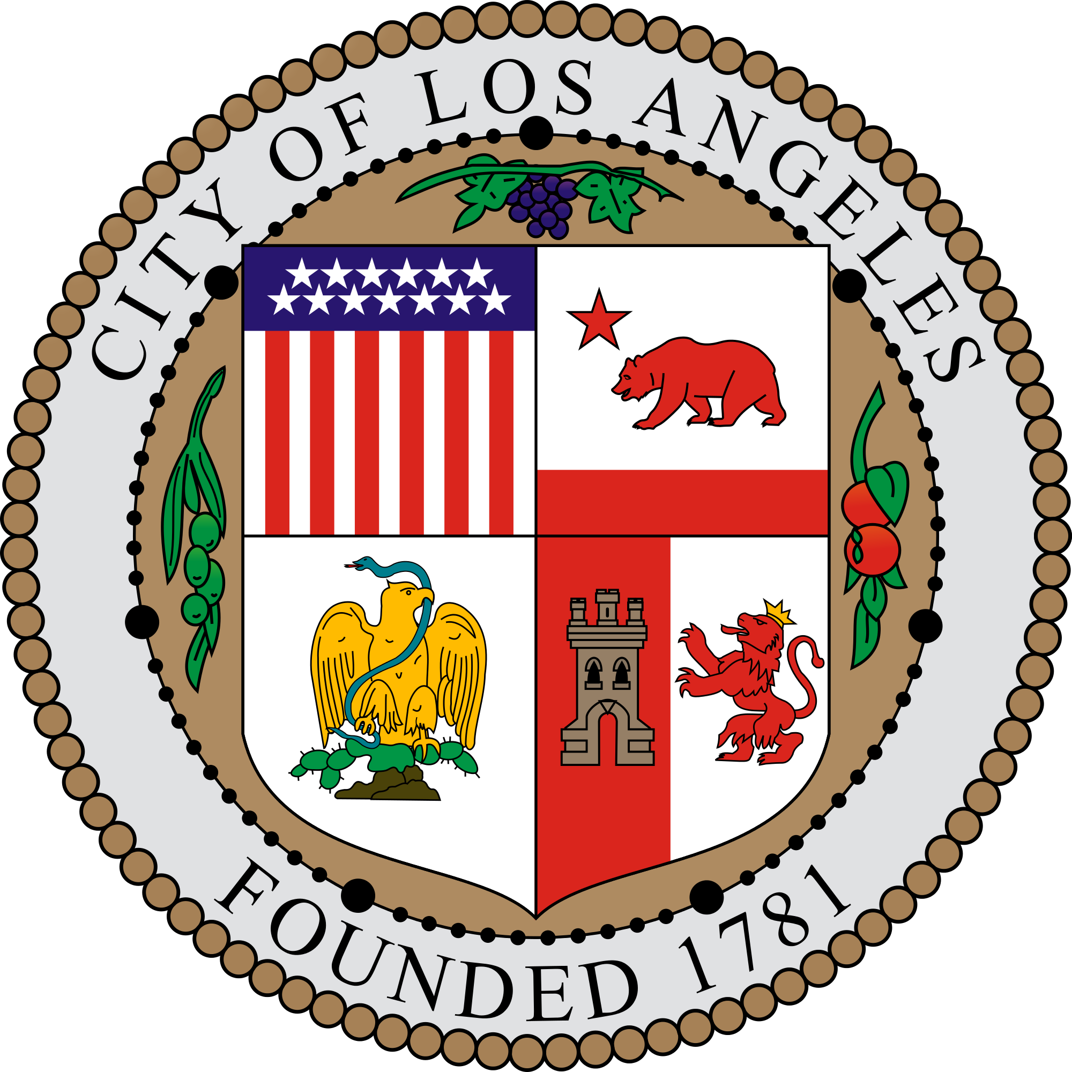
Meeting of the Land Use and Planning Committee

DATE: Thursday October 3rd, 2019 - 7 pm to 9:45 pm
Oakwood Recreation Center
767 California Ave, Venice

BOARD MEETINGS: The Venice Neighborhood Council holds its regular meetings on the third Tuesday of the month and may also call any additional required special meetings in accordance with its Bylaws and the Brown Act. All are welcome to attend.
TRANSLATION SERVICES: Si requiere servicios de traducción, favor de notificar a la oficina 3 días de trabajo (72 horas) antes del evento. Si necesita asistencia con esta notificación, por favor llame a nuestra oficina 213.978.1551.
PUBLIC ACCESS OF RECORDS: See last page.
PUBL
Name | Present | Name | Present
Alix Gucovsky, Chair | Y | Matthew Royce | N
Barry Cassilly | Y | Shep Stern | Y
Tim Bonefeld | Y | Daffodil Tyminski | N
Michael Jensen | Y | Jerome Williams | N
 |  | Carlos Zubieta | Y
IC COMMENT: See last page.
COMMUNITY IMPACT STATEMENTS: Any action taken by the Board may result in the filing of a related CIS
DISABILITY POLICY: See last page.
ALL AGENDA TIMES ARE APPROXIMATE AND SUBJECT TO CHANGE ON THE NIGHT OF THE MEETING.

AGENDA ITEMS

1. Call to Order

2. Roll Call

3. Approval of – Carlos’ motion / Tim second, Shep abstain, approved, 5-0-1
see draft minutes for September 5, 2019 at: http://venicenc.org/land-use-committee.php

4. Approval of Agenda – Carlos’ motion, Alix second, Shep abstains, Approved, 5-0-1

5. LUPC members to declare any conflicts of interest or ex parte communications relating to items on this
meeting’s agenda

6. Chair’s Report

7. General Public Comment on non-agendized items related to Land Use and Planning - 15 minutes

8. CASES FOR REVIEW
(see project files for more detailed info at http://venicenc.org/land-use-committee.php )

- Carlos recused himself and left

Case: DIR-2018-6394-SPP-CDP, ENV 2018 6395-CE
City Hearing: August 5, 2019
Address: 1043 Abbott Kinney
Applicant Jocelyn Zayco Albion Gardens
LUPC Staff Barry Cassily
Representative Ada Castellon Satoh Brothers International contact: acastellon@satohbrothers.com
City Staff Jeff Khao contact: jeff.khao@lacity.org
Case Description:
- Improvements and a 75 sq ft addition to the ground floor of a two story mixed use structure compromised of a change of use of 1090 sq ft retail use to 381 sq ft of retail use, 664 sq ft of a café (restaurant) use having 293 sq ft of Service Floor area, and 81 sq ft of beauty salon use. No work proposed to the second-floor residential use (duplex). A total of 9 parking spaces are provided, 4 existing spaces are maintained in a detached garage and 5 spaces are provided offsite of which 1 space will be replaced with 4 bicycle parking spaces.
- Director of planning shall consider an exemption from CEQA pursuant to CEQA guidelines, section 15301 and determine that there is no substantial evidence demonstrating that an exception to the categorical exemption pursuant to CEQA guidelines, section 15300.2 applies.
- Pursuant to LAMC section 12.20.2 a coastal development permit for the change of use and addition to the ground floor of an existing two-story, mixed use building, on a lot located in the single permit jurisdiction of the California Coastal Zone.
- Pursuant to LAMC section 11.5.7 a project permit compliance review for a project within the Venice Coastal Zone Specific Plan Area.

Public Comment & Possible Action:
Motion by Barry approve as presented, Tim Second, Shep abstains, Approved 4-0-1

9. Other

- VENICE MEDIAN OPEN SPACE ZONING MUST NOT BE CHANGED TO COMMERCIAL ZONING IN THE L.A. GENERAL PLAN VENICE COMMUNITY PLAN, THE CERTIFIED VENICE LOCAL. COASTAL PROGRAM LAND USE PLAN, AND THE VENICE COASTAL ZONE SPECIFIC PLAN

WHEREAS:
- The Venice median is located on Open Space in the Dual Permit Jurisdiction Coastal Zone, just one block from the beach and the center of the Venice Boardwalk;

- The Venice community—including the beach, the Boardwalk, the Venice Canals, and the eclectic architectural styles of the neighborhoods—is one of the most popular visitor destinations in California with 16 million people visiting annually (Venice Chamber of Commerce website. 2017), and thus the land use and character of the Venice community are matters of statewide significance;

- Recent government studies have documented that Venice has a significant deficit with respect to parks and other types of Open Space; L.A.

General Plan Venice Community Plan ("VCP”):
- The L.A. General Plan Venice Community Plan has an objective to preserve existing Open Space resources and where possible to develop new Open Space, as the purpose of Open Space is for the preservation of natural resources, managed production of resources and wildlife corridors, outdoor recreation, connecting neighborhoods and people, and the protection of life and property due to natural hazards;

- The VCP states that communities must have sufficient Open Space in order to balance new urban development in the community, in order to serve the recreational, environmental, health and safety needs of the community, and to protect environmental and aesthetic resources;

- The VCP states that land designated as Open Space represents only 16% of the Venice Community Plan area, and includes the beach, the canals, Ballona Lagoon and the esplanades, the Venice Blvd median, and the parks; and that the City should preserve facilities and park space by designating City recreation and park facilities as Open Space;

- The VCP directs that Open Space function in one or more of the following ways: recreational and education opportunities, scenic, cultural and historic value, public health and safety, preservation and creation of community identity, rights of way for utilities and transportation facilities, preservation of physical resources or ecologically important areas, and preservation of physical resources...;

Coastal Act:
- Coastal Act Section 30213 states: "Lower cost visitor and recreational facilities shall be protected, encouraged and where feasible, provided. Development providing public recreational opportunities is preferred;"

- Coastal Act Section 30220 states: "Coastal areas suited for water-oriented recreational activities that cannot readily be provided at inland water areas shall be protected for such uses;"

- Coastal Act Section 30224 states: "Increased recreational boating use of coastal waters shall be encouraged, in accordance with this division, by developing dry storage areas, increasing public launching facilities, providing additional berthing space in existing harbors, limiting non-water dependent land uses that congest access corridors and preclude boating support facilities, providing harbors of refuge, and by providing for new boating facilities in natural harbors, new protected water areas, and in areas dredged from dry land;”

- The Coastal Act requires and it is to L.A.’s significant economic advantage that Venice Beach be made more attractive to beachgoers, tourists and other visitors, by improving beach access while enhancing Venice Beach as a destination, with some combination of expanded parking, perhaps a transportation terminal, expansion of Open Space, expansion of restrooms, showers and other tourist facilities, and a visitor’s center;

Certified Venice Local Coastal Program Land Use Plan (“LUP"):
- The LUP Recreational Opportunities Policy III.A.1. General states: "New recreational opportunities should be provided, and existing recreational areas shall be protected, maintained and enhanced for a variety of recreational opportunities for both residents and visitors, including passive recreational and educational activities, as well as active recreational uses….acquisition, expansion and improvement of parks and facilities throughout the Venice Coastal Zone shall be encouraged and accelerated…..where feasible and compatible with the surrounding neighborhood, recreational uses shall be located in conjunction with other new public facilities, such as public parking lots, and recreation facilities shall be refurbished and constructed to maximize recreational opportunities;"

- The LUP Policy Recreational Opportunities Implementation Strategies states:
"…The City shall maintain an inventory of vacant land suitable for potential acquisition as public Open Space, and shall encourage continuing efforts by County, State and Federal agencies to acquire such land and work with the Quimby funds, the Tide-Lands Oil Trust Funds, and the Venice Surplus Real Property Fund. Unutilized or underutilized public land (including rights-of-way), particularly publicly-owned lands having potential for multiple uses, such as school playgrounds, should be made available for park and recreational uses;"

- The LUP Policy Coastal Waterways Policy III.D.2. Boating Use of Canals states:
"…A public boat launch facility was built as part of the Venice Canals Rehabilitation Project at the Grand Canal and North Venice Blvd. The City shall protect the public’s ability to access the canals by boat by maintaining public access to the Grand Canal public boat launch. The facility shall provide adequate on-site public parking consistent with the sizes and types of boats to be launched and frequency of launching pursuant to the County Department of Small Craft Harbors standards;"

- The LUP Coastal Waterways Policy III.D.6. Venice Canals Parks states:
"New parks, with parking to the rear, shall be considered on some of the City-owned lots on the canals, provided that such facilities are compatible with the existing residential use of the area;”

- The LUP Parking Policy II.A.1. General states:
“It is the policy of the City to provide increased parking opportunities for both visitors and residents of Venice, and improve summer weekend conditions with respect to Venice Beach parking and traffic control;"

- The LUP Policy II.A.2. Expansion of Public Beach Parking Supply states:
"The construction of new public parking facilities should be implemented, as well as maximizing the use of existing ones by restriping existing parking lots or converting them to multi-level structures where consistent with other Coastal Act policies…the established Venice Coastal Parking Impact Trust Fund, into which in-lieu parking fees shall be paid, will continue to be utilized for expenditure on improvement and development of public parking facilities that improve public access to the Venice Coastal Zone as specified in the LUP;”

Venice Coastal Zone Specific Plan Ordinance:
- Section 14. Venice Coastal Parking Impact Trust Fund (“Fund”) states:
"The Fund shall be used for the purpose of accepting and retaining funds collected by the Department of Transportation pursuant to this Specific Plan for any expenditure only for parking mitigation measures in, adjacent to or serving the Beach Impact Zone. Those improvements shall include but not be limited to: Venice Blvd median public parking facility improvement, including land acquisition and construction….;"

Sea Level Rising, Dewatering, Tsunami, Flooding and other Hazards:
19. There is a high water-table at the Venice median site that will present challenges for construction;

20. The dewatering of the Venice median site will have significant adverse impacts to the adjacent Venice Canal ecosystem, habitats and wildlife, in addition to producing significant noise during the initial dewatering construction phase as well as ongoing noise associated with any dewatering operations that may be required on a periodic basis after construction;

21. The Venice median sits squarely in a designated tsunami zone, and designated flood hazard areas have been
significantly increased in recent years in light of climate change and sea level rise;

22. The Venice Canals are experiencing leakage;

23. The City of Los Angeles, the California Coastal Commission and other authorities, including government
engineers, predict that sea level rise and tsunami hazards pose significant threats to the Venice median and
surrounding area, and the Venice median, along with other lower-lying areas of Venice, is projected to be
underwater in less than 50 years;

24. The Venice Local Coastal Program currently under review is focusing its response to sea level rise primarily on
"managed retreat” (surrendering as opposed to protecting imperiled properties);

25. The Venice Blvd corridor is Venice’s primary rescue and emergency escape artery, especially in case of
tsunami;

26. Elimination of Open Space and construction of a large development on the Venice median could amplify the impact of a tsunami and other flooding events on surrounding structures, including the historic Venice Canals, by impeding, deflecting or otherwise redirecting flood waters, while significantly impeding escape and evacuation;

Other:
27. The Venice Canals area is listed on the National Register of Historic Places as The Venice Canals Historic District, and the Federal designation for the area is for Community/Recreational Planning;

28. The City of L.A. has already destroyed the vast majority of the Venice Canals system (and attendant features) for which Venice is named and first gained its worldwide reputation, and what little remains today must be assiduously protected;

29. Councilmember Bonin campaigned on express promises that he would preserve Open Space, put an end to spot zoning and require that new developments be consistent with the surrounding community;

30. There are no substitutes for the Venice median for purposes of addressing the significant and growing parking deficit in Venice;

31. As per at least the last two Councilmembers for the area, the In Lieu Parking fees that have historically been paid into the Venice Coastal Parking Impact Trust Fund were to go towards expansion of parking, specifically on the Venice median, in order to mitigate the impact on public parking of the additional residential and commercial parking requirements for which the fees were paid;

32. Additional restrooms are sorely needed near the Boardwalk, and the Venice median location is the best and only available location for this visitor-serving, recreation-related use;

33. There does not appear to be a shortage of commercial uses in the area and there is no demonstrated demand that would support a conversion from Open Space to commercial use, while there clearly IS a shortage of Open Space and parking in the area;

34. Once our precious and limited Open Space is converted to another zoning classification, it’s gone forever;

THEREFORE BE IT RESOLVED:
The Venice Neighborhood Council strongly recommends that the City Council and the Coastal
Commission DENY CPC-2018-7344-GPAJ-VZCJ-HD-SP-SPP-CDP-MEL-WDI-SPR requesting amendments to the L.A. General Plan Venice Community Plan, the certified Venice Local Coastal Program Land Use Plan, and the Venice Coastal Zone Specific Plan for a Zone Change for the Venice median from Open Space to Neighborhood Commercial.

Letters to go to: Jonathan Hershy at city planning, Mike Bonin, Jason Patrick Douglas, Steve Hudson, Jack
Ainsworth, Mayor Eric Garcetti,

This recommendation will also be presented in a CIS format to the City.

Public Comment & Possible Action: Motion by Tim to continue the motion with the condition that Venice Community Housing give a presentation by Jan 31, 2020, Michael second, Approved 6-0

It was suggested by Shep that the agenda doc be used as a guide for the presentation so that all the concerns are addressed.

B. Requirements for MTA Bridge Housing
Tim recused himself

The VNC requests Councilman Bonin and Mayor Garcetti, require the service provider(s) of the Venice Bridge Housing Project located at the MTA yard implement the following Land Use conditions based on the fact that the project was approved administratively without any conditions of approval due to the fact that a categorical exemption and Coastal De Minimis Waiver were issued. The conditions outlined below will promote a safer environment for the residents and visitors of Venice, occupants of the facility and service provider staff.

The City is building a large Bridge Housing project on the 3-acre MTA property at 100 Sunset Avenue in Venice, which is within the Coastal Zone and surrounded on all four sides by residences.
The City plans to build structures to house 154 people along with various types of support, professional and security staff to serve them.
The Bridge Housing is supposed to be transitional housing, with homeless people staying only three to four months until they get permanent housing, permanent supportive housing, shared housing, reunified with families, etc.
The facility is intended to operate until June 2022 at which time it is to be removed and construction is to begin on a mix of market rate and affordable housing, parking and possibly retail.

The following will be constructed on the site as part of the temporary Bridge project:
1. A three-story semi-permanent “tent” building which will house 100 adults in a dormitory setting.
2. Six manufactured modular buildings that will house another 54 teenagers and young adults, separated by sex.
3. Separate buildings for restrooms, showers and laundry facilities.
4. Several additional buildings to house the offices of social service staff, housing locaters, security personnel, and those who will provide intake services, psychological counseling, job training, resume preparation, and skills training.
5. A large outdoor dining area.
6. An outdoor kennel for residents’ pets.
7. A facility for creation of public art.
8. A outdoor dining facility, and food preparation facilities, for 154 residents plus staff.
9. A storage building for the possessions of the 154 residents.

1. Confirm there will be sound barrier panels surrounding the MTA lot. If the design stays as we've seen it printed, the dog-run and teenage trailers will be placed very close to residences on the North side of the facility. Residences near Sunset will require this as the proximity is so close.
2. The condemned building at the South end of the lot MUST be fenced off. If so, this will act as a sound buffer for those on Thornton.
3. HVAC systems must be in concert with ambient sounds of the neighborhood at night. When there isn't a siren on Main or Pacific, it's a very quiet neighborhood.
4. The stadium type lights (already installed) should be positioned not to shine in residences.
5. What types of lighting will be installed at the Main/Sunset entrance?
6. That the operator of the facility be required to meet monthly with a committee of residents who live within 500 feet of the MTA to hear and respond to resident concerns
7. That the operator will provide a telephone number that is staffed 24 hours a day to receive and respond to emergencies and resident concerns.
8. The telephone number from item 10 above be posted on large signs on all 4 sides of the facility.
9. A tracker to be kept with all calls made to this telephone number reporting the type of incident, how it was resolved, time, date, etc. The public has access to this tracker.
10. Full transparency and monthly updates on all costs (construction and operating costs): the name of each company, detail costs and profit margin. Along with full disclosure of any and all relationships between these contractors/vendors/suppliers and government.
11. Transparency and ongoing update of number of people served and current new location (supportive housing, back with family, rehab, jail, moved on to another bridge housing, and unknown).

Public Comment & Possible Action: Motion by Michael to continue to the first meeting in Nov, assign two staff members to reach out to the applicant and the city, Carlos second, Approved 5-0

PUBLIC INPUT AT NEIGHBORHOOD COUNCIL MEETINGS: The public is requested to fill out a “Speaker Card” to address the Land Use & Planning Committee on any agenda item before the Land Use & Planning Committee takes action on an item. Comments from the public on agenda items will be heard only when the respective item is being considered. Comments from the public on other matters not appearing on the agenda that are within the Land Use & Planning Committee jurisdiction will be heard during the General Public Comment period. Please note that under the Brown Act, the Land Use & Planning Committee is prevented from acting on a matter that you bring to its attention during the General Public Comment period; however, the issue raised by a member of the public may become the subject of a future Land Use & Planning Committee meeting. Public comment is limited to 1 minute per speaker, unless adjusted by the presiding officer.

POSTING: In compliance with Government Code section 54957.5, non-exempt writings that are distributed to a majority or all of the board members in advance of a meeting may be viewed at Beyond Baroque, 681 Venice Blvd; Venice Public Library, 501 S. Venice Blvd; and at our website by clicking on the following link: www.venicenc.org, or at the scheduled meeting. You can also receive our agendas via email by subscribing to L.A. City’s Early Notification System at www.lacity.org/your-government/governmentinformation/subscribe-meetings-agendas-and-documents/neighborhood. In addition, if you would like a copy of any record related to an item on the agenda, please contact chair-lupc@venicenc.org

RECONSIDERATION AND GRIEVANCE PROCESS: For information on the VNC’s process for board action reconsideration, stakeholder grievance policy, or any other procedural matters related to this Council, please consult the VNC Bylaws. The Bylaws are available at our Board meetings and our
website www.venicenc.org.

DISABILITY POLICY: THE AMERICAN WITH DISABILITIES ACT - As a covered entity under Title II of the Americans with Disabilities Act, the City of Los Angeles does not discriminate on the basis of disability and, upon request, will provide reasonable accommodation to ensure equal access to its programs, services and activities. Sign language interpreters, assistive listening devices and other auxiliary aids and/or services, may be provided upon request. To ensure availability of services, please make your request at least 3 business days (72 hours) prior to the meeting you wish to attend by contacting George Francisco, VP, at (310) 421- 8627 or email vp@venicenc.org.

PUBLIC ACCESS OF RECORDS: In compliance with Government Code section 54957.5, non-exempt writings that are distributed to a majority or all of the Board in advance of a meeting may be viewed at our
website: www.venicenc.org or at the scheduled meeting. In addition, if you would like a copy of any record
related to an item on the agenda, please contact George Francisco, VP, at (310) 421-8627 or
email vp@venicenc.org

